

MGEC Executive Board Candidate Information
2023-2024 Term

Office you are running for
Director |  |  | Secretary |  |  | Vice President | X

Name: Mohammad Dehdashti P.E.

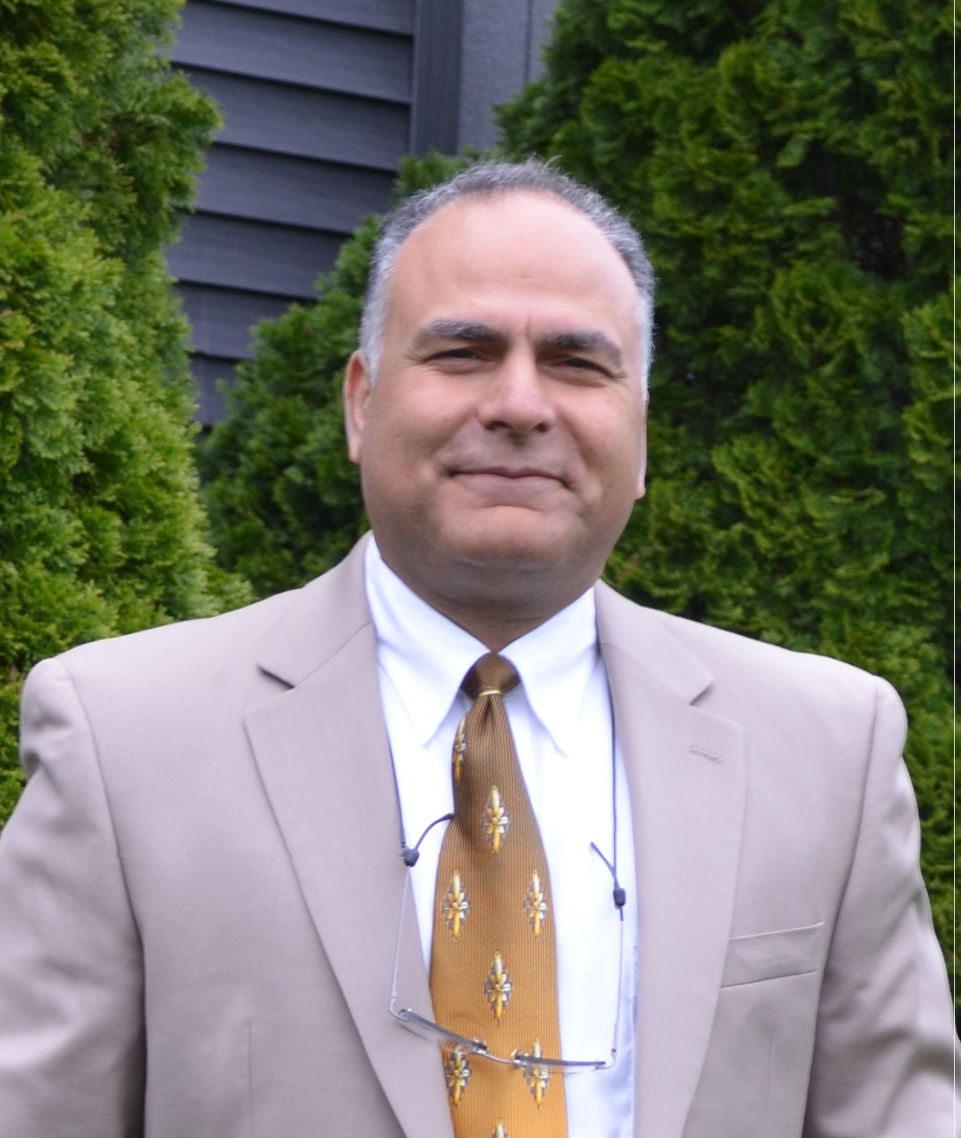photo will go here

Job Classification: Engineer Administrative Professional

Current Agency/Office your work in: MnDOT, Metro Design

Work Address: 1500 West County Rd. B2 Work Phone: 651-234-7606
Roseville, MN 55113

Email: mohammad.dehdashti@state.mn.us

Professional Licenses: Yes

Previous/Current offices held with MGEC (list years) | Board Member | X |  | Officer | X
Previous/Current offices held with MGEC (list years) | Negotiations | X |  | Committee Member | X
Previous/Current offices held with MGEC (list years) | Contact person |  |  | Instructor

Number of years working for the State | 34 | Number of years a full MGEC member | 34

Why are you running for an MGEC office?

As a past President, I recognize one of the most important things MGEC does for its members is work to improve terms and conditions of employment. I want to continue our negotiations for equitable wages with MMB. This has been a top priority of the membership for every contract. We’ve made progress improving our past contracts, especially compensation, by trying different approaches with MMB through intense negotiations.

We still have more to do. I offer my experience and leadership to that end. We have successes (vacation to deferred compensation, supervisor pay differential, range adjustments and creation of a new class, Engineering Specialist Principal) to build on with improved communication (upgraded email and website), full staff complement, and regular meetings with members. Let’s work together.

Additional information you want to share with members:

I enjoy family activities, outdoors, hunting, and fishing.

